PROJECT TITLE

NETFLIX MOVIE Prediction System

Team Id: PY-PT78

Problem Id: 17

Name : VARDAN BANSAL (Team Leader)
Class Roll Number: 78
University Roll Number : 2028903
Section and Group: P(G2)

Name : DIVYANSH SILSWAL
Class Roll Number: 42
University Roll Number : 2028713
Section and Group: P(G2)

Name : PRIYANSH RAUTELA
Class Roll Number: 60
University Roll Number : 2028808
Section and Group: P(G2)

TABLE OF CONTENTS
- Problem Description .......................................................................................3
  - Dataset Description....................................................................................4-5
  - Flow diagram..............................................................................................6
- Modules for Project Implementation…………………..……………………
  - Modules Used............................................................................................7-9
  - Platform Used...........................................................................................10
- Machine Learning model/ Searching Technique used ................................11-12
- Evaluation metrics used .................................................................................13-14
- Results and Visualizations ............................................................................15-22
- Conclusion and Future Scope ........................................................................23-24
- References ........................................................................................................25

- Problem Description
With the increasing popularity of online streaming platforms like Netflix, users are presented with a vast collection of movies and shows, making it challenging to find content that matches their interests. Therefore, there is a need for an intelligent system that can automatically predict user preferences and provide personalized recommendations.

This project focuses on developing a machine learning-based system that predicts whether a user will like or dislike a movie based on their historical rating data. The dataset includes user IDs, movie IDs, ratings, and timestamps. Since raw data may contain inconsistencies, preprocessing steps such as handling missing values, removing duplicate records, normalizing ratings, and encoding categorical variables are performed.

To improve prediction accuracy, relevant features such as user viewing behavior, movie popularity, and past rating patterns are extracted and selected.
The problem is formulated as a binary classification task:
- 1 → High Rating / Recommended
- 0 → Low Rating / Not Recommended

Different machine learning models, including Logistic Regression, K-Nearest Neighbors (KNN), and Support Vector Machine (SVM), are trained and compared. The models are evaluated using performance metrics such as accuracy, precision, recall, F1-score, confusion matrix, and ROC curve.
The main objective of this system is to build an efficient and reliable movie recommendation model that enhances user experience by suggesting relevant content based on their preference

1.1 Dataset Description

This dataset contains viewing records from Netflix, capturing user engagement with movies and TV shows across diverse global content.

- Total Rows : 8,807
- Total Columns : 12
- Valid Records (non-null) : 7,926

1. User_ID - string
Unique identifier for each user (e.g., P1757, P3523). Represents the person who watched the content. There are 4,401 unique users in the dataset.
2. Movie_ID – string
Unique identifier for each movie/show on Netflix (e.g., s1, s2, s3). There are 7,926 unique titles.
3. Category - string
Type of content. Only 2 possible values:
Movie and TV Show
4. Title - string
The name of the movie or TV show (e.g., Dick Johnson Is Dead, Kota Factory). Has 7,926 unique titles.
5. Country - string
Country where the content was produced. 748 unique countries/combinations present. Top 5:
6. Timestamp – string
Date and time when the user watched the content (format: DD/MM/YYYY HH:MM:SS). Has 7,836 unique timestamps.
7. Release_Year – float
The year the content was originally released. Range spans nearly a century:

8. Rating – float
Numerical rating of the content on a scale of 1.0 to 10.0:

9. Duration – string
Runtime of the content. Movies show minutes (e.g., 90 min), TV shows show seasons (e.g., 2 Seasons). Has 216 unique duration values.
10.Genere - string
Genre(s) of the content, comma-separated for multi-genre titles. Has 500 unique genre combinations. Top genres:
11.Language - string
Original language of the content. Only 9 unique languages:
12. DubbedLanguages – string
Comma-separated list of languages the content has been dubbed into (e.g., Hindi, Spanish). Has 807 unique combinations.

1.2 Flow Diagram

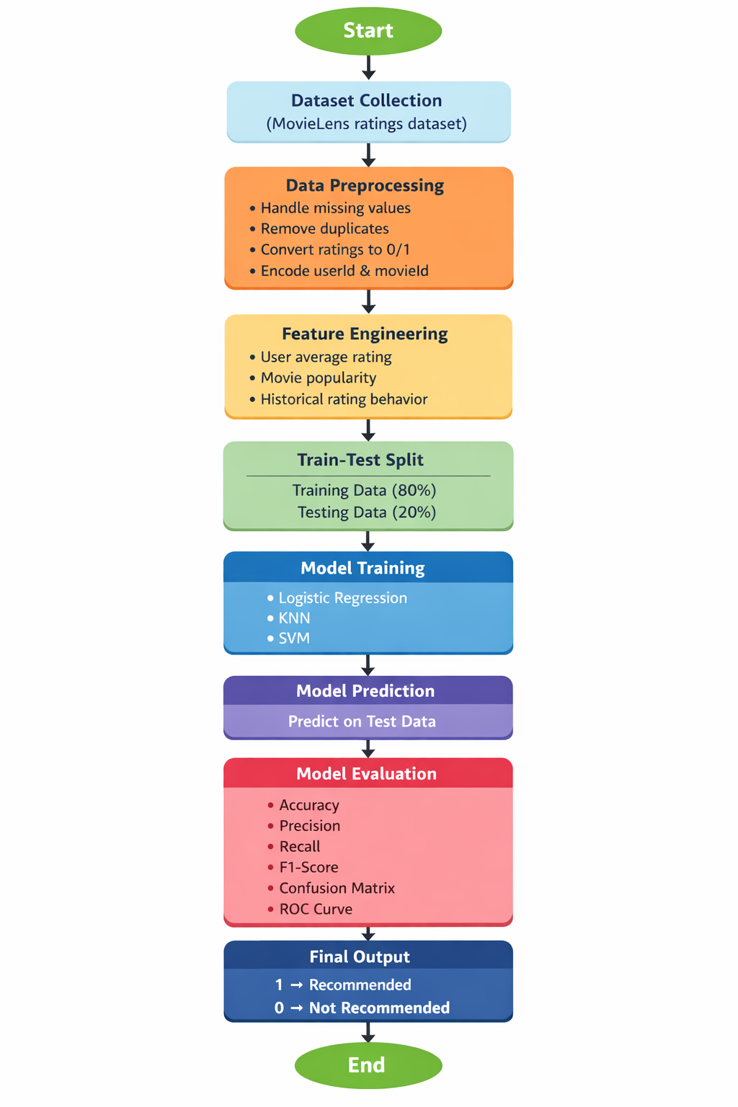

2. Modules for Project Implementation

2.1 Modules Used

Data Handling

- Pandas – Used for loading and manipulating dataset
Functions used:

- pd.read_csv() → Load dataset
- df.drop_duplicates() → Remove duplicate rows
- df.fillna() → Replace missing values
- df.apply() → Apply function row-wise
- pd.Series() → Create index mapping
- df.iloc[] → Access rows by index
- df.head() — Displays the first 5 rows to preview the data.
- df.shape — Returns the dimensions of the DataFrame
- df.drop() — Removes columns
- df['col'].dropna() — Drops null/NaN values
- df['col'].str.lower() — Converts string column values to lowercase for consistent matching.
- df['col'].value_counts() — Counts occurrences of each unique value in a column (used for pie chart).

Text Processing & Similarity
- fit_transform() → Convert text → numerical vectors
- sklearn.linear_model.LogisticRegression
A classification model used to predict whether a user would watch a title. Trained on the scaled feature set.

- sklearn.preprocessing.LabelEncoder
Converts categorical text columns (like User_ID, Title, Genre, Country, etc.) into numeric integer labels so machine learning models can process them.
Evaluation Metrics

- sklearn.metrics : is a module in the Scikit-learn library that provides functions to evaluate the performance of machine learning models.
roc_curve
auc
accuracy_score
confusion_matrix
precision_score
recall_score
f1_score

Visualization

- matplotlib.pyplot (plt) : → Used for plotting graphs

- plt.plot() → Plot ROC curve
- plt.xlabel() → Label X-axis
- plt.ylabel() → Label Y-axis
- plt.title() → Add title
- plt.legend() → Show legend
- plt.show() → Display graph
- plt.pie() — Draws the "Movies vs TV Shows" pie chart with percentage labels.

- seaborn (as sns)
A higher-level visualization library built on matplotlib. Used for styled heatmaps, count plots, and setting the plot theme
- sns.heatmap — Draws a correlation matrix heatmap with annotated values.

PYTHON BUILT IN FUNCTION USED

- list() → Convert to list
- sorted() → Sort similarity scores
- lambda → Custom sorting logic
- input() → Take user input
- print() → Display output
- range() (implicitly via slicing

2.2 Platform Used:

  - Jupyter:

In Jupyter we can run code step-by-step (cell by cell) instead of running the whole program at once.
This makes debugging and learning much easier.

Jupyter allows you to display:
- Graphs
- Charts
- Tables
directly below your code using libraries like:
- matplotlib
- seaborn

3. Machine Learning Model/ Searching Technique Used(Describe each ML model/ searching technique used)

Logistic Regression
A supervised classification algorithm that predicts the probability of a binary outcome (0 or 1).

LabelEncoder (Preprocessing)
Converts categorical text columns into numeric integers so ML models can process them.

Machine Learning (KNN Model)
- sklearn.model_selection
train_test_split : Splits the dataset into two parts — one for training the model and one for testing its performance

- sklearn.preprocessing

StandardScaler : Scales features so that mean = 0 and std = 1, by subtracting mean and dividing by standard deviation

MinMaxScaler : Scales features to a fixed range (default 0 to 1) by using minimum and maximum values of each column

- sklearn.neighbors
KNeighborsClassifier : Classifies a data point based on the majority class of its K nearest neighboring points in the dataset

- lr.fit(X_train, y_train) — Trains the Logistic Regression model.
- lr.predict(X_test) — Generates predictions on the test set

Support Vector Machine (SVM)

- Concept: SVM is a powerful classification algorithm that plots all data points in an n-dimensional space and attempts to find the "optimal hyperplane" (a mathematical boundary) that best separates the different classes with the maximum possible margin.
- Application in this Project: User preferences are rarely strictly linear; a user might like Sci-Fi movies but only if they were released after 2010. SVM uses a technique called the "Kernel Trick" to handle these complex, non-linear relationships. It will draw a precise boundary separating the features of movies the user previously rated highly from those they rated poorly.
- Why we chose it: SVM is highly effective in high-dimensional spaces, making it perfect for datasets with multiple encoded categorical features (like dozens of Movie IDs and genres). It is robust against outliers and generally provides higher accuracy for complex classification tasks compared to basic linear mode

Custom modules

- Rule-Based Recommendation System

(recommend_movie_to_user)

- Only recommends movies with a rating of 7.0 or above

- Collects all genres from user's watch history
- Checks if the new movie shares at least one genre
- Uses set intersection logic

- Considers both original language and dubbed versions
- Only recommends if user is familiar with the language

- Smart Score-Based Recommendation (match_score)

  - A scoring-based content filter that ranks all movies by how many genres match the user's preferences.

  - For every movie in the dataset, count how many of the user's preferred genres appear in it
  - Assign that count as a score
  - Sort all movies by score (highest first)
  - Remove the movie the user already watched
  - Display top 10 most similar movies

4. Evaluation metrics used (Describe each evaluation metric used along with formulae)

- Accuracy Score

measures what percentage of total predictions were correct.

Accuracy = (True Positives + True Negatives) / (Total Predictions)
= (TP + TN) / (TP + TN + FP + FN)

- Precision Score

Measures how many of the predicted positives were actually positive

Precision = True Positives / (True Positives + False Positives)

= TP / (TP + FP)

- Recall Score

Measures how many actual positives were correctly identified.

Recall = True Positives / (True Positives + False Negatives)

= TP / (TP + FN)

- F1 Score

The harmonic mean of Precision and Recall — balances both metrics into a single score. Useful when you need both precision and recall to be high.

F1 Score = 2 × (Precision × Recall) / (Precision + Recall)

= 2TP / (2TP + FP + FN)

5. Results and Visualizations

6. Conclusion and Future Scope:

This project successfully developed a Netflix Movie Recommendation System using a combination of Machine Learning classification and rule-based content filtering techniques. The system was built on a dataset of 8,807 watch records from 4,401 users across 7,926 unique titles, covering movies and TV shows

Data Analysis & Exploration

- Performed thorough Exploratory Data Analysis (EDA) on the Netflix dataset
- Visualized content distribution through pie charts (Movies vs TV Shows — 63% vs 37%)
- Generated a correlation heatmap to understand relationships between numeric features
- Identified and handled approximately 10% missing data across all columns
- Applied LabelEncoding to convert 8 categorical columns into numeric form for ML processing

Machine Learning Model

- Built and trained a Logistic Regression classifier to predict whether a user would watch a given title
- Applied StandardScaler for feature normalization to ensure fair model training
- Used stratified train-test split (30% train / 70% test) to maintain class balance
- Achieved outstanding performance across all evaluation metrics:

FUTURE SCOPE

1. Transition to Deep Learning Models
Traditional models like Logistic Regression and SVM are good baselines, but modern systems rely heavily on deep learning:

2. Real-Time Personalization
Current system is likely static. Future systems can:
- Adapt recommendations based on recent activity
- Use online learning algorithms
- Update predictions dynamically as users interact

3. Deployment as a Real Application
Take it beyond a model:
- Build a web app (Flask/Django) or API
- Integrate with a frontend UI

4. Improve recommendations for:
- New users (no history)
- New movies (no ratings)

7. References:
Books:
- Let Us Python – Yashavant Kanetkar
- Aurélien Géron – Hands-On Machine Learning with Scikit-Learn
- Tom Mitchell – Machine Learning

Online Resources:
- Scikit-Learn Official Documentation – https://scikit-learn.org/
- Pandas & NumPy Documentation – https://pandas.pydata.org/
- Kaggle Datasets (Netflix Data) – https://www.kaggle.com/
- Stack Overflow – https://stackoverflow.com

